MAY 2013

Part A

Answer ​all ​questions. Each question carries ​3 ​marks.

1.Explain file handling utilities. Ans:
touch:

The touch command creates the new file you specify, and assigns your username as the file owner. Since I used the -il parameters for the ls command, the first entry in the listing shows the inode number assigned to the file. Every file on the Linux system has a unique inode number.

Notice that the file size is zero, since the touch command just created an empty file. The touch command can also be used to change the access and modification times on an existing file without changing the file contents:

$ touch test1

cp:

Copying files and directories from one location in the filesystem to another is a common practice. The cp command provides this feature. In it’s most basic form, the cp command uses two parameters: the source object and the destination

cp source destination

When both the source and destination parameters are filenames, the cp command copies the source file to a new file with the filename specified as the destination. The new file acts like a brand new file, with an updated file creation and last modified times:

$ cp test1 test2

Renaming files:

In the Linux world, renaming files is called moving. The mv command is available to move both files and directories to another location:

$ mv test2 test6

2. What is a tee command?
Ans.
Tee command is used to store and view (both at the same time) the output of any other command. Tee command writes to the STDOUT, and to a file at a time as shown in the examples below.
The following command displays output only on the screen (stdout).

$ ls

The following command writes the output only to the file and not to the screen.

$ ls > file

The following command (with the help of tee command) writes the output both to the screen (stdout) and to the file.

$ ls | tee file

3.With examples show the usage of grep commands. Ans.
grep searches the named input FILEs (or standard input if no files are named, or if a single hyphen-minus (-) is given as file name) for lines containing a match to the given pattern. By default, grep prints the matching lines.

To Search for the given string in a single file test.sh

$ cat test.sh #!/bin/bash fun()

echo "This is a test."

# Terminate our shell script with success message exit 1

fun()

from above file grep exit:

$ grep "exit" demo_file

output:

​exit 1

4.List the features of BASH-Shell. Ans.
- Redirection- it support redirection of input,output and errors.

- Tee command -copies standard input to standard output and at same time copies it into one or more files

- Pipe operator- temporarily saves the output of one command in a buffer that is being used at the same time as the input of next command

- Command substitution- converts the output of a command to a string

- Aliases- creating customized commands by assigning a name to a command (Syntax : alias name=command-definition)

- Allows multiple jobs at a time(foreground & background jobs)

5.What is dns? Explain. Ans.
The Domain Name System (DNS) is a central part of the Internet, providing a way to match names (a website you’re seeking) to numbers (the address for the website). Anything
connected to the Internet - laptops, tablets, mobile phones, websites - has an Internet Protocol (IP) address made up of numbers. Your favorite website might have an IP address like 64.202.189.170, but this is obviously not easy to remember. However a domain name such as bestdomainnameever.com is something people can recognize and remember. DNS syncs up domain names with IP addresses enabling humans to use memorable domain names while computers on the Internet can use IP addresses.
(5*3 = 15 marks) Part B
Each question carries ​5​marks.

6.Draw and explain the architecture of UNIX.

Ans:
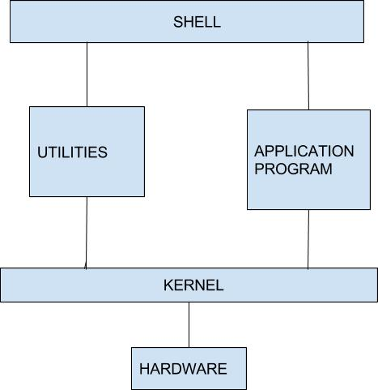

  - Kernel − The kernel is the heart of the operating system. It interacts with the hardware and most of the tasks like memory management, task scheduling and file management.

  - Shell − The shell is the utility that processes your requests. When you type in a command at your terminal, the shell interprets the command and calls the program that you want. The shell uses standard syntax for all commands. C Shell, Bourne Shell and Korn Shell are the most famous shells which are available with most of the Unix variants.

- Utilities ​: The utilities reside on the computer's disk and are only brought into memory as requested. Virtually every command you know under the Unix system is classified as a utility; therefore, the program resides on the disk and is brought into memory only when you request that the command be executed.
7. Explain the steps for the concatenation of files. Ans:
Unix provides a powerful tool to concatenate files. It is known as the catenate command(cat for short). It appends one or more files by appending them in the order they are listed in the command. The input can come from the keyboard and the output goes to the monitor.

Given one or more files , the cat command writes them one after another to standard output. The result is that all of the input files are combined and become one output. If the output file is to be saved, standard output can be redirected to a specified file.
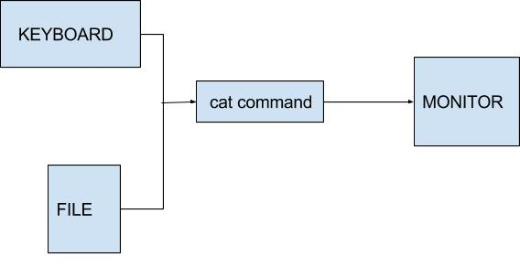

General form of cat command is :
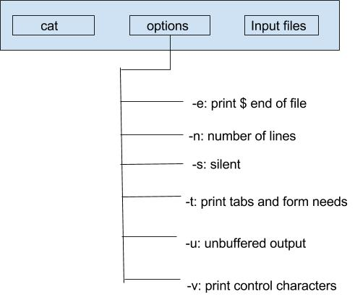

Eg: cat file1 file2 file3

This combines file1, file2 and file3 one after the other in order.

8. With examples explain different string functions. Ans.

String Length ${#string}
expr length $string

These are the equivalent of strlen() in C.

Length of Matching Substring at Beginning of String expr match "$string" '$substring'
$substring is a regular expression. expr "$string" : '$substring'

Index

expr index $string $substring

Numerical position in $string of first character in $substring that matches.

Substring Extraction ${string:position}

Extracts substring from $string at $position.

Substring Removal ${string#substring}

Deletes shortest match of $substring from front of $string.

Substring Replacement ${string/substring/replacement}
Replace first match of $substring with $replacement.

9. Explain eval command with an example. Ans:
The eval command is used when the Korn shell needs to evaluate a command twice before executing it. To generalize a segment of code, we need to store the name of a variable in a second variable and then use the print command to display the value of the original variable. $ x=23

$ y=x

$ print $y x

The solution is to use the eval command so that the shell evaluates the command twice.

$ x=23 $ y=x

$ eval print \$$y 23

When the eval command is executed, it first evaluates $y, which generates the string value $x.
The second evaluation then evaluates the variable $x, which produces the correct effect, the printing of the variable stored in y.

10. Explain the architecture of X-window. Ans:
- The X Window System was specifically designed to allow the graphical output of a program running on one machine to appear on a different machine.

- A machine running an X windowing system can launch a program on a remote computer
- All the CPU processing happens on the remote computer but the display of the application appears on the local machine
- In 1984, the Massachusetts Institute of Technology released the X Windows System.

- When MIT started working on the project, they were aware that people were working with several types of graphic displays.
- Every display has its own methods for drawing lines and shapes on the screen

- If an application were to write to all these displays, then there had to be several versions of the application– one for each type of display
- It is not a good idea to design a hundred versions of a program for so many displays

- MIT decided that the display should be handled by a separate program

- The application would instead send its output to this display-handling program.

- This led to a very important splitting of the application into client and server components.
- In a typical Windows application, the job of handling the PC’s display is handled by the client application itself
- X reverses this paradigm and its architecture places the responsibility of handling the display on the server
- The application itself runs as a client.

- The X server and clients may be on the same machine, but X shines when they are separated and was primarily designed to run over a TCP/IP network.
- The transmission is totally reliable; X uses the TCP protocol.

- X technology lets you run an X client on a remote machine and yet have the display on your own local machine
- A basic X Window System concept is the separation of applications from the software that handles terminal input and output.
- All interactions with terminal devices are managed by a dedicated program (the server) whereas applications (clients) send the server the information to be displayed.

(5*5= 25 marks)

Part C
Each question carries ​12​marks.
11. With Examples explain some basic UNIX commands. Ans:
- The date Command​:
Date command is helpful to display date in several formats. It also allows you to set Systems date and time.When you execute date command without any option, it will display the current date and time as shown below.

Dates

Mon May 20 22:02:24 PDT 2013

- The calendar Command:

cal displays a simple calendar. If arguments are not specified, the current month is displayed.

The options are as follows:

-1 Display single month output. (This is the default.)

-3 Display prev/current/next month output.

-s Display Sunday as the first day of the week.

- The who Command:

who command shows who is logged on to the system. This is a useful command for a Linux system administrator because they can check how many users currently logged in the system and who they are.

who

root tty1 2009-07-06 22:06 luzar tty7 2009-07-06 19:17 (:0)
luzar pts/0 2009-07-06 21:28 (:0.0)

- The who am i Command:

Who am i from a Linux command line terminal (and unix as well), the who command prints only the information about user who runs the command.

who am i

luzar pts/0 2009-07-06 22:39 (:0.0)

- The passwd Command:

The passwd command changes passwords for user accounts. A normal user may only change the password for his/her own account, while the superuser may change the password for any account.passwd also changes the account or associated password validity period.

sudo passwd coolcoder
Changing password for coolcoder. (current) UNIX password:
Enter new UNIX password:

Retype new UNIX password:

passwd: password updated successfully

- The echo Command:

echo command prints the given input string to standard output.

echo "hello India“

The above command will print as hello India

- The man Command

In UNIX and Linux distros, command line programs come with their own documentation called manual pages or man pages.

To read the man page of an UNIX command, pass the command name as the argument to the man. The following will display the man page for passwd command.
man passwd

PASSWD(1) User Commands PASSWD(1)

NAME

passwd - change user password

- The lpr Command

lpr submits files for printing. Files named on the command line are sent to the named printer (or the system default destination if no destination is specified). If no files are listed on the command-line lpr reads the print file from the standard input.

The following options are recognized by lpr:

-E: Forces encryption when connecting to the server -P destination: Prints files to the named printer.

- The clear Command

clear command is used to remove all previous commands and output from consoles and terminal windows in Unix-like operating systems Clear is one of the very few commands in Unix-like operating systems that accepts neither options nor arguments (i.e., input files).

clear

- The script Command
It saves a session of your terminal. In spite of saving each command per line in a text file, script makes a typescript of everything that happens on the terminal. Screencasting tools to a desktop session(GUI) is what script is to a terminal.

script

Script started, file is typescript [shredder12]$ cd [shredder12]$ ls

file1 file2 file3 [shredder12]$ exit exit

Script done, file is typescript

It saves a session of your terminal .In spite of saving each command per line in a text file, script makes a typescript of everything that happens on the terminal. Screencasting tools to a desktop session(GUI) is what script is to a terminal.

- The Uname Command

The uname Command Sometimes it is required to quickly determine details like kernel name, version, hostname, etc of the Unux you are using

When the ‘uname’ command is run without any option then it prints just the kernel name

$uname Linux

Or

12. Describe the text processing utilities and back up. Ans.

tar command

In windows operating system, you might have used the winzip and winrar softwares for extracting and archiving the files. Similarly in unix or linux operating system, the tar command is used for creating archive files and also extracting files from the archives. With the tar command, you can also create compressed archive files. In unix or linux operating system, there are many other commands like gzip and gunzip for creating and extracting archive files.

The syntax of tar command is :

tar [options] [Archive file] [files list]

The options of tar command are: -c : creates a tar file.

-v : verbose. Displays the files information. -f : Specify the tar file name.

-r : updates the tar file with new files.

-x : Extracts files from the archive (tar file). -t : view contents of tar file.

-z : Specify the tar command to create a tar file using gzip in unix. - j : uses bzip2 to create the tar file.

Creating a tar file

Let see a sample example by archiving all the files in my current directory. The ls -l command displays the files and directories in the current directory.

ls -l

drwxr-xr-x 2 user group 4096 Aug 8 03:23 debian -rw-r--r-- 1 user group 174 Aug 2 23:39 file

-rw-r--r-- 1 user group 0 Aug 8 03:22 linux_server.bat -rw-r--r-- 1 user group 76 Aug 2 02:21 test.sh -rw-r--r-- 1 user group 0 Aug 8 03:22 unix_distro

We see how to tar all these files using the -c option with the tar command. tar -cvf archive.tar *

debian/ File

linux_server.bat test.sh unix_distro

Observe the output of ls command and see the archive.tar file is created ls

archive.tar debian file linux_server.bat test.sh unix_distro

Extracting the contents of tar file

In the first example, we have created the archive file. Now we will see how to extract the set of files from the archive.

To extract the contents of the tar file use the -x option.

tar -xvf archive.tar debian/

file linux_server.bat
test.sh unix_distro

Compressing files using gzip tar -zcvf new_tar_file.tar.gz *

To extract files from a gip compressed tar file tar -zxvf new_tar_file.tar.gz

zip command

zip is used to compress the files to reduce file size and also used as file package utility. zip is available in many operating systems like unix, linux, windows etc. If you have a limited bandwidth between two servers and want to transfer the files faster, then zip the files and transfer.

The syntax of zip command is

zip [options] zipfile files_list

-d : Removes the file from the zip archive -u : Updates the file in the zip archive

-m : Deletes the original files after zipping. -r : Recursively zips the files in a directory -x : Exclude the files in creating the zip

-v : verbose mode -1 : Compresses the files faster -9 : Compresses the files better

-f : freshen only changed files.

zipfile : creates the zip file with name as zipfile.zip files_list : list of files to be zipped.

Creating a zip file

Syntax :

zip archive linux-virtual-server.bat unix-server.dat

The above command creates the zip file with name archive.zip Extracting files from zip

Syntax :

unzip archive.zip

​13.With examples, explain the concept of pipe and pipe operator with respect to C shell.

Ans:

Pipes

- The pipe operator temporarily saves the output from one command in a buffer that is being used at the same time as the input to the next command. Temporarily saves the output of one command in a buffer that is being used at the same time as the input of next command

  - pipe is an operator, not a command (|)

  - must be placed between two commands

  - the first command must be able to send its output to a standard output
  - the second command must be able to read its input from standard input
  - pipe receives its input from standard output and send it to next command through standard input.

  - who | more

- Explain the step, with examples the concatenation and comparing of files. Ans:

Concatenation of files

The cat command is used to ​concatenates files and print it on the standard output.

SYNTAX :

cat [options] [file]

OPTIONS:

-A | Show all.
-b | Omits line numbers for blank space in the output.
-e | A $ character will be printed at the end of each line prior to a new line.
-E | Displays a $ (dollar sign) at the end of each line.
-n | Line numbers for all the output lines.
-s | If the output has multiple empty lines it replaces it with one empty line.
-T | Displays the tab characters in the output.
-v | Non-printing characters (with the exception of tabs, new-lines and form-feeds) are
-v | printed visibly.

EXAMPLE:

- To Create a new file:

​cat>file1.txt
This command creates a new file file1.txt. After typing into the file press control+d (^d) simultaneously to end the file.

- To Append data into the file:

cat>>file1.txt
To append data into the same file use append operator >> to write into the file, else the file will be overwritten (i.e., all of its contents will be erased).

- To display a file:

Cat file1.txt
This command displays the data in the file.

- To concatenate several files and display:

Cat file1.txt file2.txt

The above cat command will concatenate the two files (file1.txt and file2.txt) and it will display the output in the screen.

- To concatenate several files and to transfer the output to another file.

Cat file1.txt file2.txt > file3.txt
In the above example the output is redirected to new file file3.txt. The cat command will create new file file3.txt and store the concatenated output into file3.txt.

Comparing files

- cmp:-​The cmp utility compares two files of any type and writes the results to the standard output. By default, cmp is silent if the files are the same; if they differ, the byte and line number at which the first​ difference occurred is reported.

Syntax: ​cmp​file1 file2

- diff:-​The UNIX diff command compares the contents of two text files and outputs a list of
differences. If desired, you may instruct it to ignore spacing or case variations. This command can also verify that two files contain the same data.

Syntax:​diff​[options] from-file to-file

- comm:-​Compare sorted files FILE1 and FILE2 line by line.

Syntax: comm [OPTION]... FILE1 FILE2

With no options, produce three-column output. Column one contains lines unique to FILE1, column two contains lines unique to FILE2, and column three contains lines common to both files.
Options
-1:-suppress lines unique to FILE1

-2:-suppress lines unique to FILE2

-3:-suppress lines that appear in both files

15​.​With examples explain associative Arrays and some mathematical functions explanation and usage.

Ans:

ARRAYS IN AWK

Syntax:

arrayName[index] = value

Examples:

list[1] = "one" list[2] = "three"

list["other"] = "oh my !"

ILLUSTRATION: ASSOCIATIVE ARRAYS

awk arrays can use string as index
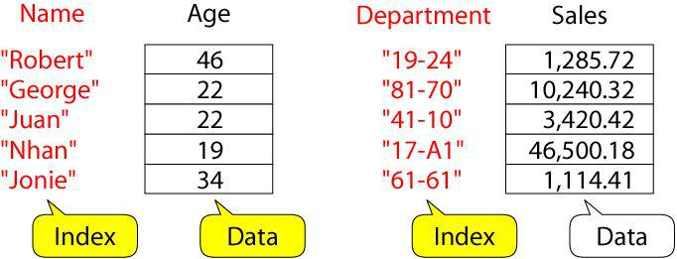

- Index must be unique: each index must be associated with an array value only once

- Data values may be duplicated

- The association of the index with its value is guaranteed

- There is no ordering imposed on the indexes

- An array index cannot be sorted. The data values in the array can be sorted.

MATHEMATICAL FUNCTIONS
- cos(x)

This gives the cosine of x, with x in radians. Eg:

awk 'BEGIN {

PI = 3.14159265 param = 60

result = cos(param * PI / 180.0)

printf "The cosine of %f degrees is %f.\n", param, result }'

op:The cosine of 60.000000 degrees is 0.500000.

- exp(x)

It gives the exponential of x (e ^ x), or reports an error if x is out of range. The range of values x can have depends on your machine's floating point representation.

Eg:

awk 'BEGIN {

param = 5

result = exp(param);

printf "The exponential value of %f is %f.\n", param, result }'

op:The exponential value of 5.000000 is 148.413159.

● log(x)

It gives the natural logarithm of x, if x is positive; otherwise, it reports an

error.

Eg:

awk 'BEGIN {

param = 5.5

result = log (param)

printf "log(%f) = %f\n", param, result }'

op:log(5.500000) = 1.704748

● sin(x)

It gives the sine of x, with x in radians.

Eg:

awk 'BEGIN {

PI = 3.14159265 param = 30.0

result = sin(param * PI /180)

printf "The sine of %f degrees is %f.\n", param, result }'

op:The sine of 30.000000 degrees is 0.500000.

- sqrt(x)

It gives the positive square root of x. It reports an error if x is negative.

Eg:

awk 'BEGIN {

param = 1024.0 result = sqrt(param)

printf "sqrt(%f) = %f\n", param, result }'

op:sqrt(1024.000000) = 32.000000

Or

16. Write system commands in awk and explain how it will be executed with examples.
Ans :

Used for processing text files, particularly data files that are organized by rows and columns.
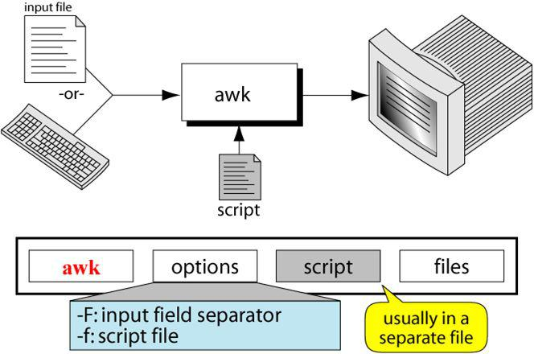

BASIC AWK SYNTAX:

awk ‘pattern{action}’ inputfile awk –f scriptfile.awk inputfile Options:

-F : to change input field separator -f : to name script file

AWK OPERATION:

- scans a file line by line

- splits each input line into fields

- compares input line/fields to pattern

- performs action(s) on matched lines

A field is a unit of data in a line. Each field is separated from the other fields by the field Separator. Default field separator is whitespace.A record is the collection of fields in a line A data file is made up of records.awk supports two types of buffers:

record and field field buffer:

one for each fields in the current record. names: $1, $2, …

record buffer :

$0 holds the entire record

awk scripts are divided into three major parts:
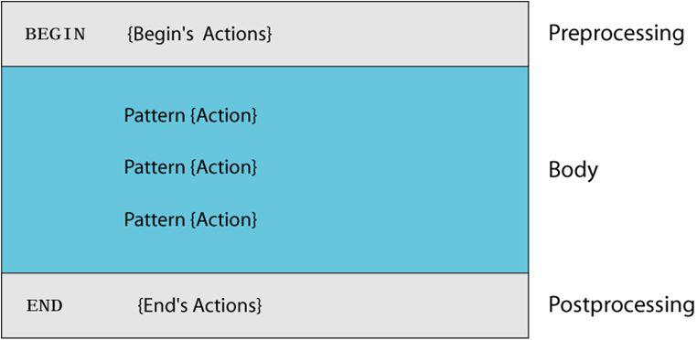

AWK SCRIPTS

BEGIN: pre-processing

- performs processing that must be completed before

the file processing starts (i.e., before awk starts reading records from the input file)

- useful for initialization tasks such as to initialize variables and to create report headings

BODY: Processing

- contains main processing logic to be applied to input records

- like a loop that processes input data one record at a

time

END: post-processing

- executed after all input data have been read

- information accumulated during processing can be analyzed and printed

AWK OPERATION EXAMPLE

BEGIN { print “totals” }

{

total = $1 + $2 + $3

print $1 “ +” $2 “+” $3 “=“ total
}

END { print “total completed”}

EXAMPLE: MATCH INPUT RECORD

% cat employees2

Tom Jones:4424:5/12/66:543354

Mary Adams:5346:11/4/63:28765

Sally Chang:1654:7/22/54:650000

Billy Black:1683:9/23/44:336500

% awk –F: '/00$/' employees2

Sally Chang:1654:7/22/54:650000

Billy Black:1683:9/23/44:336500

EXAMPLE: EXPLICIT MATCH

% cat datafile

northwest NW Charles Main 3.0 .98 3 34 western WE Sharon Gray 5.3 .97 5 23 southwest SW Lewis Dalsass 2.7 .8 2 18 southern SO Suan Chin 5.1 .95 4 15 southeast SE Patricia Hemenway 4.0 .7 4 17 eastern EA TB Savage 4.4 .84 5 20 northeast NE AM Main 5.1 .94 3 13

north NO Margot Weber 4.5 .89 5 9 central CT Ann Stephens 5.7 .94 5 13

EXAMPLES: MATCHING WITH RES

% awk '$2 !~ /E/{print $1, $2}' datafile northwest NW

southwest SW southern SO north NO central CT

17.What are environmental variables? Explain. Give a brief description of the exit status of a command.

Ans:

Environmental Variables

The environmental variables control the user environment. The table below lists the environmental variables. The environmental variables in Korn shell are in uppercase.

Variable | Explanation
CDPATH | Contains the search path for cd command when the directory
 | argument is a relative pathname.
COLUMNS | Defines the width, in characters, of your terminal. The default is
 | 80.
EDITOR | Pathname of the command-line editor.
ENV | Pathname of the environment file.
HISTFILE | Pathname for the history file.
HISTSIZE | Maximum number of saved commands in the history file.
HOME | Pathname for the home directory.
LINES | Defines the height, in lines, of your terminal display. The default
 | is 24.
LOGNAME | Contains the user’s login name from the /etc/passwd file.
MAIL | Absolute pathname for the user’s mailbox.
MAILCHECK | Interval between tests for new mail. The default is 600 seconds.
MAILPATH | List of files to be checked for incoming mail.
OLDPWD | Absolute pathname of the working directory before the last cd
 | command.
PATH | Searches path for commands.
PS1 | Primary prompt, such as $ and %.
PS2 | Secondary prompt. Used when complete command not entered
 | on first line. The default is >.
PS3 | Select command prompt. Used ony for select commands. The
 | default is #?.
PS4 | Debug prompt. The default is plus (+).
PWD | Absolute path name of the current directory.
RANDOM | Returns a random number each time it is called.
REPLY | Temporary buffer for read command.
SECONDS | Time in seconds since the shell was invoked.
SHELL | Pathname of the logging shell.
TERM | Terminal type.
TMOUT | Variable that determines how long a terminal may be idle before
 | it is automatically logged out of the system. The default is 0,
 | which means the session will never timeout.
VISUAL | Same as EDITOR. However, VISUAL has precedence over
 | EDITOR. If VISUAL is set, the system does not check the value
 | of EDITOR.

C-shell

The environment variables control the user environment. In the C shell, there are two types of environmental variables: uppercase and lowercase. By tradition, the uppercase variables are set to be exportable and the lowercase variables are not. However this is not a rule enforced by the C shell.

Options

We use options in the Korn shell to control the way its commands are executed.

Option Explanation

allexport | Sets all variable to be exported.
emacs | Use emacs for command-line editing and history file.
ignoreeof | Disallows ctrl+d to exit the shell.
noclobber | Does not allow redirection to clobber existing file.
noexec | Reads and syntactically checks commands in a script.
noglob | Disables wildcard expansion.
verbose | Prints commands before executing them.
vi | Uses vi for command-line editing and history file.
xtrace | Prints commands and arguments before executing them.

Export All (allexport)

When the allexport option is set, all variables are automatically flagged for exporting when they are assigned a value.

No Execute (noexec)

The noexec option must be set in a script; it cannot be used interactively. We use it to check the syntax of a script before we run it. When it is the first command in a script, then the script interpreter simply reads the script and checks for syntax errors. If no errors are found, the command-line prompt is displayed. If it finds an error, it displays an error message and stops.

No Global (noglob)

The noglob option controls the expansion of wildcard tokens in a command. For example, when the no global option is off, the list file (ls) command uses wildcards to match the files in a directory.

$ ls file?

file? file1 file2 file3 $ set -o noglob

$ ls file? file?

Verbosity (verbose)

The verbose option shows commands before they are executed by the shell. It is useful when debugging a script.

Execute Trace (xtrace)

The xtrace option displays the command with a plus sign (+) and the evaluation of the expression in each step of a command script. Like the verbose option, it is a debugging tool.

C-shell

In C shell, only the following options are present. They behave the same way as in Korn shell.

Option | Explanation
noglob | Disables wildcard expansion.
verbose | Prints commands before executing them.
noclobber | Does not allow redirection to clobber existing file.
ignoreeof | Disallows ctrl+d to exit the shell.

Handling Options

The customize our shell environment, we need to set, unset and display options.

Operation | Command
Set | set –o option
Unset | set +o option
Display All | set –o
C-shell
Operation | Example
Set | set noglob
Unset | unset noglob
Display All | set

Exit status of a command
​C SHELL

- In the C shell, when a command is executed, it returns a value known as the exit status of the command.
- The exit status is stored in a shell variable with a name status.

- The exit status is accessible by using its name $status.

- If a command completes successfully, it returns a zero value, which is interpreted as true; if it does
not complete successfully, it returns a nonzero value, which is interpreted as false.

KORN SHELL

- In the Korn shell, when a command is executed, it returns a value known as the exit status of the command.
- The exit status is stored in a shell variable with a name of (?).

- The exit status is accessible by using its name ($?).

- If a command completes successfully, it returns a zero

value, which is interpreted as true; if it does not complete successfully, it returns a nonzero value, which is interpreted as false.

ls file*

File1 file2 file3 print $?

0

$ ls none

Cannot access none: No such file or directory print $?

2

Or

18.Explain argument validation and changing positional parameter in detail. Show examples.

Ans:

Special Parameters and Variables

The Korn shell provides both special parameters and special variables for out use. We discuss them in this section.

Special Parameters

Besides having positional parameters numbered 1 to 9, the Korn shell script can have four other special parameters: one that contains the script filename, one that contains the number of arguments and two that combine all other parameters.

Script Name ($0)

The script name parameter ($0) holds the name of the script. This is often useful when a script calls other scripts. The script name parameter can be passed to the

called script so that it knows who called it. When a script needs to issue an error message, it can include its name as part of the message.

Number of Arguments ($#)

Another special parameter holds the number of arguments passed to the script. Scripts can use this parameter, referred to as $#, programmatically in several ways.

#!/bin/ksh

# Script: This script displays the $0 and $# special parameters print “The program name is: “ $0

print “Number of arguments: “ $#

All Parameters ($* and $@)

Two special parameters combine the nine positional parameters into one string. The can be used with or without quotes.

All Parameters without Quotes

When we use $* and $@ without quotes, they create a list of parameters. The number of elements in the list is the same as the number of arguments. The following script shows the parameter in turn using a loop.

#!/bin/ksh

# Loops displaying parameter list one element at a time for parm in $*

do

print $parm

done

All Parameters With Quotes

When the all parameters tokens are used inside quotes, their behaviour is different. The quoted string token (“$*”) means combine all arguments into one single string (“$1 $2 $3 $4 $5 $6 $7 $8 $9”). When used as a list, the list has only one member – a string containing all arguments. On the other hand, the quoted list token (“$@”) creates a string list in which each argument is a separate string (“$1” “$2” “$3” “$4” “$5” “$6” “$7” “$8” “$9”). To further demonstrate the differences, look at the following script that takes a set of arguments and processes them first as a single string ($*) and tehn as a string list ($@).

#!/bin/ksh

# Demonstrates difference between $* and $@ special parameters

print “The program name is: “ $0
print “Number of arguemntes: “ $# ”\n”

print “Display arguments as a single string ($*): ‘ i=0

for x in “$*” do

(( i = i + 1 ))

print “Loop” I “is:” “$x”

done

print “At end of string loop: I is:” $i “\n”

print ‘Display arguments as a list ($@): ‘ i=0

for x in “$@” do

(( i = i + 1 ))

print “Loop” $i “is:” “$x”

done

print “At end of list loop: i is:” $i

Output

students@firewall:~/test$ ./parmLoop2.scr One Two "Buckle my shoe" The program name is: ./parmLoop2.scr

Number of arguemntes: 3

Display arguments as a single string (One Two Buckle my shoe): Loop I is: One Two Buckle my shoe

At end of string loop: I is: 1

Display arguments as a list (One Two Buckle my shoe):

Loop 1 is: One

Loop 2 is: Two

Loop 3 is: Buckle my shoe

At end of list loop: i is: 3

19.Discuss with examples the client server mechanism and address resolution.

Ans:

Network management

When you work in a distributed environment then you need to communicate with remote users and you also need to access remote Unix machines.. There are
several Unix utilities which are especially useful for users computing in a networked distributed environment.

The ping utility

The ping command send an echo request to a host available on the network. Using this command we can check if our remote host is responding well or not. The ping command is useful for
1.​ Tracking​ and isolating hardware and software problems

2.​ Determining​ the status of the network and various foreign hosts and 3.​ Testing,​ measuring and managing networks.

In a ping command, we use a remote host’s name or IP address as argument. Sample output is given below:
root@firewall:~# ping 192.168.0.150

PING 192.168.0.150 (192.168.0.150) 56(84) bytes of data.

64 bytes from 192.168.0.150: icmp_req=1 ttl=128 time=4.00 ms 64 bytes from 192.168.0.150: icmp_req=2 ttl=128 time=0.258 ms 64 bytes from 192.168.0.150: icmp_req=3 ttl=128 time=0.257 ms ^C

--- 192.168.0.150 ping statistics ---

3 packets transmitted, 3 received, 0% packet loss, time 2000ms rtt min/avg/max/mdev = 0.257/1.508/4.009/1.768 ms

The time shown in each line is the “round-trip” time taken by a special (ICMP) packet to reach its destination and come back. Here, we see a well-connected local area network with a good response time and no “packet loss”. For wide area networks, the round-trip time would be in the order of several milliseconds – which could still be within the acceptable range. If the packets arrive randomly, there could be some packet loss as well.

When the host is “down or unreachable”, you will see this after the interrupt key is pressed.

Client server mechanism, address resolution, ping, telnet, ftp

dns

Small networks rely on /etc/hosts to perform mappings of host names to IP addresses but with the advent of World Wide Web the entries grew exponentially; thus making it very difficult to use and maintain the consistency of its entries. A hierarchical structure for hostnames, with distributed database to perform the name-address mappings needed to be developed. Such features were provided in
DNS (Domain Name System) service. Along with the above features, authority was delegated to individual levels of the hierarchy. Internet namespace has a structure like the UNIX file system. It has a tree of domains with an unnamed root domain called . (dot). This root domain has a number of top level domains under it. A second domain under the first domain is knows as a sub-directory under a main directory. The Internet domain structure is a backbone of the Internet. The root level domains are organized as an inverted tree-like structure just as in UNIX. The top-level domains are listed below:
Int | Stands for International Organizations
Edu | Signifies Educational Institutions
Gov | US Gov Organizations
Mil | US Military Organization
Org | Non-profit Organization
Com | Commercial Organization
Net | Networking Organization
Arpa | Domain for Reverse Resolution
In | India
Uk, ch, us etc | United Kingdom, China, USA etc.

Typically a company gets one domain name and uses sub-domains for its branches or sites. The second level domain (oxford in smith.eng.oxford.edu) in the US is allotted by the InterNIC in USA. The dot-separated string is parsed from right to left. So from root to to domain ‘edu’ then to ‘oxford’, then to ‘eng’ and there contact ‘smith’ hostname.

and squid –

Or

20.With proper examples describe the window system. Ans:

X Window System

The X Window System was specifically designed to allow the graphical output of a program running on one machine to appear on a different machine.A machine running an X windowing system can launch a program on a remote computer .All the CPU processing
happens on the remote computer but the display of the application appears on the local machine

In 1984, the Massachusetts Institute of Technology released the X Windows System. The X architecture

When MIT started working on the project, they were aware that people were working with several types of graphic displays.Every display had its own methods for drawing lines

and shapes on the screen.If an application were to write to all these displays, then there had to be several versions of the application

– one for each type of display

It is not a good idea to design a hundred versions of a program for so many displays MIT decided that the display should be handled by a separate program

The application would instead send its output to this display-handling program.

This led to a very important splitting of the application into client and server components.

In a typical Windows application, the job of handling the PC’s display is handled by the client application itself X reverses this paradigm and its architecture places the responsibility of handling the display on the server.The application itself runs as a client.The X server and clients may be on the same machine,but X shines when they are separated and was primarily designed to run over a TCP/IP network.

The transmission is totally reliable; X uses the TCP protocol.X technology lets you run an X client on a remote machine and yet have the display on your own local machineA basic X Window System concept is the separation of applications from the software that handles terminal input and output.All interactions with terminal devices are managed by a dedicated program (the server) where as applications (clients) send the server the information to be displayed.

Starting and stopping X

Most systems will automatically start the X Window System with the command xdm from /etc/inittab.On systems that don’t start an X server for you at login time, there is usually a command such as xinit or startx that you can either type manually add to your login or profile script so that it will be started automatically when you log in.The xinit program will read the

.xinitrc to configure itself when it is started. There is no standard way of quitting the X. One method is to point the cursor anywhere on the desktop or an edge of the screen and press one of the mouse buttons.

If this brings up a menu, see if there is an option like “Exit Session” or “Log out”. The other method is for sessions started with xinit it may be possible to use the exit command in that xterm window seen on starting X.

x clients and display

There are a number of X clients, the most common being xterm, xclipboard and

xclock.

xterm
The xterm is the most important X client. It comes up when X is started with xinit. Xterm behaves like any character-based terminal. An xterm window is an instance of the shell.

